Name:Pranav Sarda
Gr No: 21810773
Roll No: 321047
Div: A-2

3 B :-
%{
/*
* Word recognizer with a symbol table.
*/
enum{
LOOKUP = 0, /* default-looking rather than defining. */
VERB,
ADJ,
ADV,
NOUN,
PREP,
PRON,
CONJ,
INT
};
int state;
int add_word(int type, char *word);
int lookup_word(char *word);
%}
%%
\n {state = LOOKUP; }
/* whenever a line starts with a reserved part of speech name */
/* start defining words of that type */
^verb { state = VERB; }
^adj { state = ADJ; }
^adv { state = ADV; }
^noun { state = NOUN; }
^prep { state = PREP; }
^pron { state = PRON; }
^conj { state = CONJ; }
^int { state = INT; }
/* a normal word, define it or look it up */
[a-zA-Z]+ {
if(state != LOOKUP) {
/* define the current word */
add_word(state, yytext);
} else {
switch(lookup_word(yytext)) {
case VERB: printf("%s: verb\n", yytext); break;
case ADJ: printf("%s: adjective\n", yytext); break;
case ADV: printf("%s: adverb\n", yytext); break;
case NOUN: printf("%s: noun\n", yytext); break;
case PREP: printf("%s: preposition\n", yytext); break;
case PRON: printf("%s: pronoun\n", yytext); break;
case CONJ: printf("%s: conjunction\n", yytext); break;
case INT: printf("%s: interjection\n", yytext); break;
default:
printf("%s: don't recognize\n", yytext) ;
break;
}
}
}
. /* ignore anything else */;
%%
int yywrap(void)
{

}
int main()
{
yylex();
}
/* define a linked list of words and types */
struct word{
char *word_name;
int word_type;
struct word *next;
};
struct word *word_list; /* first element in word list */
extern void *malloc();
int add_word(int type,char *word)
{
struct word *wp;
if(lookup_word(word) != LOOKUP) {
printf (" ! ! ! warning: word %s already defined \n",word);
return 0;
}
/* word not there, allocate a new entry and link it on the list */
wp = (struct word *) malloc(sizeof(struct word) );

wp->next = word_list;

/* have to copy the word itself as well */
wp->word_name = (char *) malloc(strlen(word)+1);
strcpy(wp->word_name,word);
wp->word_type = type;
word_list = wp;
return 1; /* it worked */
}
int lookup_word(char *word)
{
struct word *wp = word_list;
/* search down the list looking for the word */
for (; wp; wp = wp->next) {
if(strcmp(wp->word_name, word) == 0)
return wp->word_type;
}
return LOOKUP; /* not found */
}

OUTPUT :-
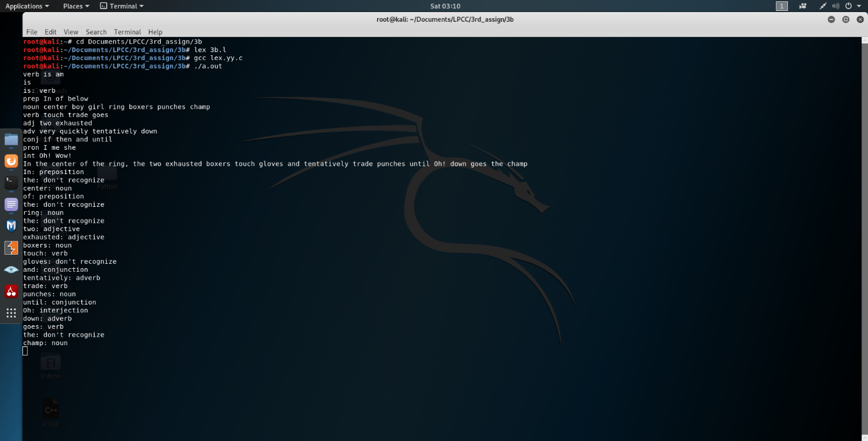

3D :-
%{
/*
* Word recognizer with a symbol table.
*/
enum {
LOOKUP =0, /* default - looking rather than defining. */
KEYWORD,
IDENTIFIER,
NUMBER,
LOGICAL,
ARITHMETIC,
RELATIONAL,
FORMAT,
PUNC,
ASSIGN
};
int state;
int add_word(int type, char *word);
int lookup_word(char *word);
%}
%%
\n { state = LOOKUP; } /* end of line, return to default state */
/* whenever a line starts with a reserved part of speech name */
/* start defining words of that type */
^keyword { state = KEYWORD; }
^identifier { state = IDENTIFIER; }
^number { state = NUMBER; }
^logical { state = LOGICAL; }
^arithmetic { state = ARITHMETIC; }
^relational { state = RELATIONAL; }
^format { state = FORMAT; }
^punc { state = PUNC; }
^assign { state = ASSIGN; }
[a-zA-Z0-9\.&&\|\|\+-\/%\*\<\>==\<=\>=%d%s%f%s\{\}\,\;\':\"\?\!()]+ {
/* a normal word, define it or look it up */
if(state != LOOKUP) {
/* define the current word */
add_word(state, yytext);
} else {
switch(lookup_word(yytext)) {
case KEYWORD: printf("%s: keyword\n", yytext); break;
case IDENTIFIER: printf("%s: identifier\n", yytext); break;
case NUMBER: printf("%s: number\n", yytext); break;
case LOGICAL: printf("%s: Logical operator\n", yytext); break;
case ARITHMETIC: printf("%s: Aritmetic operator\n", yytext); break;
case RELATIONAL: printf("%s: Relational operator\n", yytext); break;
case FORMAT: printf("%s: Format Specifier\n", yytext); break;
case PUNC: printf("%s: Punctuation Symbol\n", yytext); break;
case ASSIGN: printf("%s: Assignment Op\n", yytext); break;
default:
printf("%s: didn't recognize\n", yytext);
break;
}
}
}
. /* ignore anything else */ ;
%%
int yywrap(void)
{

}
int main()
{
yylex();
}
/* define a linked list of words and types */
struct word {
char *word_name;
int word_type;
struct word *next;
};
struct word *word_list; /* first element in word list */
extern void *malloc() ;
int
add_word(int type, char *word)
{
struct word *wp;
if(lookup_word(word) != LOOKUP) {
printf("!!! warning: word %s already defined \n", word);
return 0;
}
/* word not there, allocate a new entry and link it on the list */
wp = (struct word *) malloc(sizeof(struct word));
wp->next = word_list;
/* have to copy the word itself as well */
wp->word_name = (char *) malloc(strlen(word)+1);
strcpy(wp->word_name, word);
wp->word_type = type;
word_list = wp;
return 1; /* it worked */
}
int
lookup_word(char *word)
{
struct word *wp = word_list;
/* search down the list looking for the word */
for(; wp; wp = wp->next) {
if(strcmp(wp->word_name, word) == 0)
return wp->word_type;
}
return LOOKUP; /* not found */
}

OUTPUT :-

